Seasonal characteristics of fine and nanoparticles observed at the tip of Noto peninsula, Japan
A. Matsuki¹, Y. Iwamoto¹, Sara Kagami², K. Kinouchi² and R. Yamada²,
¹Institute of Nature and Environmental Technology, Kanazawa University, Kanazawa 9201192, Japan
²College of Science and Engineering, Kanazawa University, Kanazawa 9201192, Japan
Email: matsuki@staff.kanazawa-u.ac.jp

Description of the measurement site
The East Asia is identified as one of the global hotspots of atmospheric aerosols. The outflow of atmospheric pollutants along with Asian dust is increasingly concerned in connection with their impacts on the public health and regional climate. In order to conduct in-situ aerosol characterization in the East-Asian outflow over extended periods, a new ground-based research station “NOTOGRO” (acronym for NOTO Ground-based Research Observatory) has been established in Suzu city (37.45ºN, 137.36ºE) at the tip of Noto peninsula.
Noto peninsula stems from the north-western coast of mainland Japan. Such a geographical setting is considered ideal for an additional baseline atmospheric monitoring station in East Asia (Fig. 1), since it is surrounded by the sea and isolated from any neighboring city and other pollution sources.

New Particle Formation (NPF)
New Particle Formation (NPF) of atmospheric aerosol particle is an important process which controls the number concentration of the aerosol particles that would act as Cloud Condensation Nuclei (CCN) and potentially affect the global climate. It is estimated that up to 45% of global CCN involved in low-level cloud activation at 0.2% supersaturation are secondary aerosol derived from nucleation [1].
The number size distribution of atmospheric aerosols was measured at NOTOGRO from October 2012 and September 2013. We identified NPF events throughout the measurement period. Comparing with the local meteorological parameters, NPF events were concentrated in daytime, which suggests interaction with solar radiation. Further, NPF events tended to occur when Condensation Sink (CS) was relatively low (CS is a measure of the amount of preexisting particle concentration and depends on the particle size distribution). Precipitation preceding the event was suggested to trigger NPF events by lowering CS (i..e preexisting particle concentration) especially in winter and summer. On the other hand, NPF events observed in autumn and spring tended to concentrate on days with particularly low relative humidity. Above results suggested that, the conditions favorable for the NPF event is closely related to the seasonal climatic features of the measurement region, that are, the winter monsoon in winter, the rainy season and typhoon in summer and anticyclones in autumn and spring.

- J. Merikanto et al., Impact of nucleation on global CCN, Atmos. Chem. Phys., 9, 8601–8616 (2009)
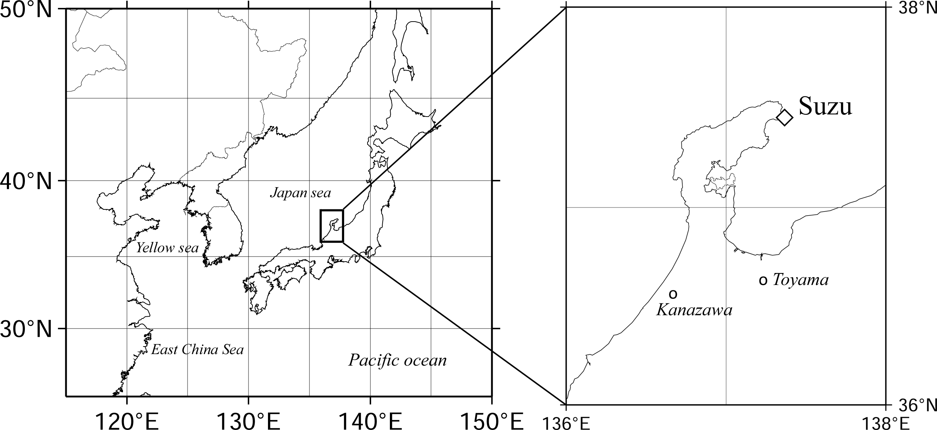
Fig. 1 Geographical setting of NOTOGRO station.

